Right Triangular Pyramid
# Source: AI Source: Provided by: [Data Path: Persons Table -> ID Column: 1, Name_En Column: Motasem Essam] -> From: [ChatGPT] on [7/25/2026]
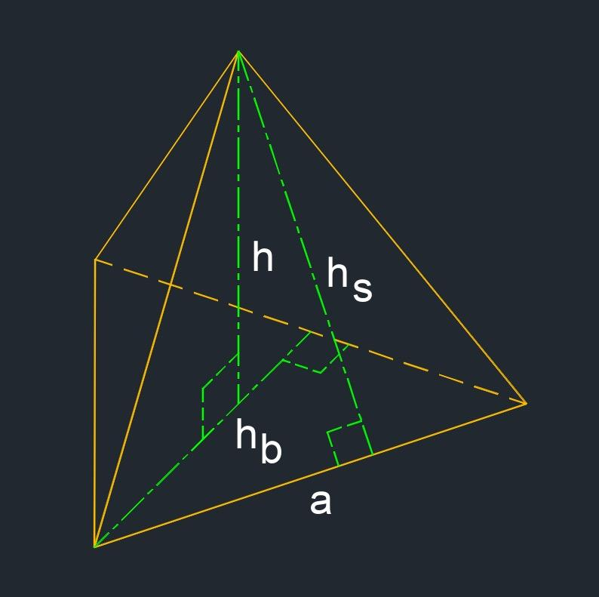

Definition
# Source: AI Source: Provided by: [Data Path: Persons Table -> ID Column: 1, Name_En Column: Motasem Essam] -> From: [ChatGPT] on [7/25/2026]
A right triangular pyramid is a triangular pyramid in which the perpendicular from the apex to the plane of the triangular base meets the base at its designated center.
It has one triangular base and three triangular lateral faces. The apex lies directly above the base center, and the pyramid's height is perpendicular to the base plane.
Important distinction: The word right describes the position of the apex relative to the base, not the presence of a right angle in the base triangle. A right triangular pyramid does not necessarily have a right-triangular base.
For an irregular triangular base, the term center needs to be specified because different definitions of a triangle's center can produce different locations. In many introductory treatments, the intended center is the centroid.

Simple Definition
# Source: AI Source: Provided by: [Data Path: Persons Table -> ID Column: 1, Name_En Column: Motasem Essam] -> From: [ChatGPT] on [7/25/2026]
A right triangular pyramid is a pyramid with a triangular base whose apex is directly above the center of the base, so its height meets the base plane at a right angle.

Key Characteristics
# Source: AI Source: Provided by: [Data Path: Persons Table -> ID Column: 1, Name_En Column: Motasem Essam] -> From: [ChatGPT] on [7/25/2026]
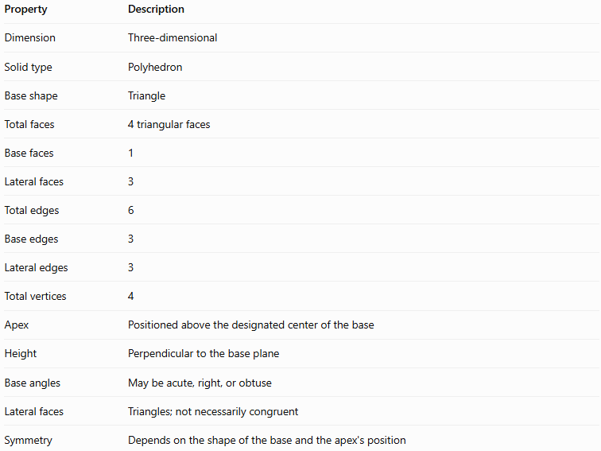
Property | Description
Dimension | Three-dimensional
Solid type | Polyhedron
Base shape | Triangle
Total faces | 4 triangular faces
Base faces | 1
Lateral faces | 3
Total edges | 6
Base edges | 3
Lateral edges | 3
Total vertices | 4
Apex | Positioned above the designated center of the base
Height | Perpendicular to the base plane
Base angles | May be acute, right, or obtuse
Lateral faces | Triangles; not necessarily congruent
Symmetry | Depends on the shape of the base and the apex's position

Geometric Representation
# Source: AI Source: Provided by: [Data Path: Persons Table -> ID Column: 1, Name_En Column: Motasem Essam] -> From: [ChatGPT] on [7/25/2026]
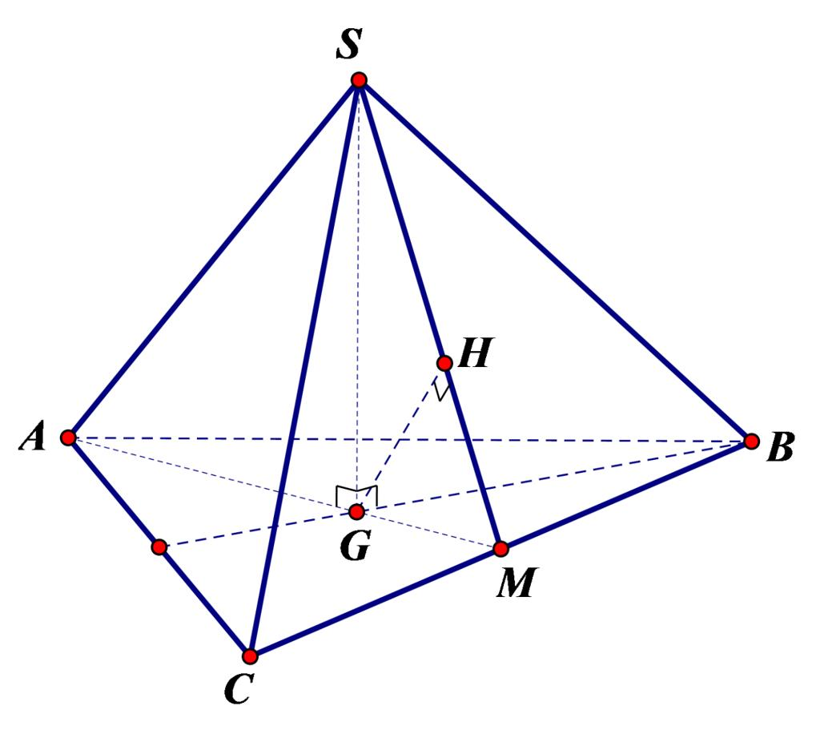
A right triangular pyramid consists of these components:
- Triangular base $ABC$: The triangle that forms the bottom or designated base.
- Apex $S$: The vertex above the base center.
- Base center $G$: The specified center of the base triangle, often its centroid.
- Perpendicular height $SG$: The shortest distance from the apex to the plane of the base.
- Base edges $AB$, $BC$, and $CA$: The three sides of the base triangle.
- Lateral edges $SA$, $SB$, and $SC$: The edges connecting the apex to the base vertices.
- Lateral faces $SAB$, $SBC$, and $SCA$: The three triangular side faces.
The defining geometric relationship is:
$$SG⊥\text{plane}\left(ABC\right)$$
Therefore, the height $SG$ forms a ${90}^{∘}$ angle with every line in the base plane passing through $G$.

Mathematical Representations and Formulas
# Source: AI Source: Provided by: [Data Path: Persons Table -> ID Column: 1, Name_En Column: Motasem Essam] -> From: [ChatGPT] on [7/25/2026]
Let:
- $B$ = area of the triangular base.
- $h$ = perpendicular height.
- $A_{T}$ = total surface area.
- $A_{L}$ = lateral surface area.
- $P_{b}$ = perimeter of the base.

Number of faces, edges, and vertices
# Source: AI Source: Provided by: [Data Path: Persons Table -> ID Column: 1, Name_En Column: Motasem Essam] -> From: [ChatGPT] on [7/25/2026]
For a pyramid with an $n$-sided base:
$$F=n+1, E=2n, V_{e}=n+1$$
For a triangular pyramid, $n=3$:
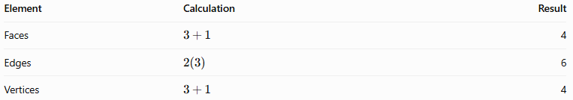
Element | Calculation | Result
Faces | $$3+1$$ | 4
Edges | $$2\left(3\right)$$ | 6
Vertices | $$3+1$$ | 4
Euler's formula for convex polyhedra is:
$$V_{e}-E+F=2$$
Substituting:
$$4-6+4=2$$
The right triangular pyramid satisfies Euler's formula.

Volume
# Source: AI Source: Provided by: [Data Path: Persons Table -> ID Column: 1, Name_En Column: Motasem Essam] -> From: [ChatGPT] on [7/25/2026]
The volume formula for every pyramid is:
$$\boxed{V=\frac{1}{3}Bh}$$
If the base triangle has base length $b$ and perpendicular triangle altitude $h_{b}$, its area is:
$$B=\frac{1}{2}bh_{b}$$
Therefore:
$$\boxed{V=\frac{1}{6}bh_{b}h}$$
Here, $h_{b}$ is the height of the base triangle, whereas $h$ is the perpendicular height of the entire pyramid.

Total surface area
# Source: AI Source: Provided by: [Data Path: Persons Table -> ID Column: 1, Name_En Column: Motasem Essam] -> From: [ChatGPT] on [7/25/2026]
The total surface area is the sum of the base area and the three lateral face areas:
$$\boxed{A_{T}=B+A_{1}+A_{2}+A_{3}}$$
The lateral surface area is:
$$\boxed{A_{L}=A_{1}+A_{2}+A_{3}}$$
For a right triangular pyramid, the three lateral faces do not necessarily have the same slant height. Unless additional symmetry is present, calculate their areas individually.

6.4 Height, lateral edges, and base-center distance
# Source: AI Source: Provided by: [Data Path: Persons Table -> ID Column: 1, Name_En Column: Motasem Essam] -> From: [ChatGPT] on [7/25/2026]
Suppose the apex is directly above the base center $G$, the perpendicular height is $h$, and a base vertex $A$ is at distance $GA=r_{A}$.
Triangle $SGA$ is right-angled at $G$. By the Pythagorean theorem:
$$\boxed{SA=\sqrt{h^{2}+r_{A}^{2}}}$$
Likewise:
$$SB=\sqrt{h^{2}+GB^{2}}$$
$$SC=\sqrt{h^{2}+GC^{2}}$$
These equations show that the lateral edges are equal only when the corresponding base vertices are equally distant from the chosen center.

Worked Examples
# Source: AI Source: Provided by: [Data Path: Persons Table -> ID Column: 1, Name_En Column: Motasem Essam] -> From: [ChatGPT] on [7/25/2026]
Example 1: Identifying the elements
A right triangular pyramid has a triangular base. Determine the number of faces, edges, and vertices.
Solution:
- Faces: $3+1=4$
- Edges: $2\left(3\right)=6$
- Vertices: $3+1=4$
Answer: The pyramid has 4 faces, 6 edges, and 4 vertices.
Example 2: Calculating volume
A right triangular pyramid has a base triangle with base $8\text{ cm}$ and perpendicular altitude $6\text{ cm}$. The pyramid's perpendicular height is $9\text{ cm}$.
Step 1: Calculate the base area.
$$B=\frac{1}{2}\left(8\right)\left(6\right)=24{\text{ cm}}^{2}$$
Step 2: Calculate the volume.
$$V=\frac{1}{3}\left(24\right)\left(9\right)$$
$$\boxed{V=72{\text{ cm}}^{3}}$$
Answer: The volume is $72{\text{ cm}}^{3}$.
Example 3: Calculating a lateral edge
Suppose the perpendicular height is $12\text{ cm}$, and the distance from the base center to vertex $A$ is $5\text{ cm}$.
Using the Pythagorean theorem:
$$SA=\sqrt{{12}^{2}+5^{2}}$$
$$SA=\sqrt{144+25}=\sqrt{169}$$
$$\boxed{SA=13\text{ cm}}$$
Answer: The lateral edge $SA$ is $13\text{ cm}$.

Comparison with Related Concepts
# Source: AI Source: Provided by: [Data Path: Persons Table -> ID Column: 1, Name_En Column: Motasem Essam] -> From: [ChatGPT] on [7/25/2026]
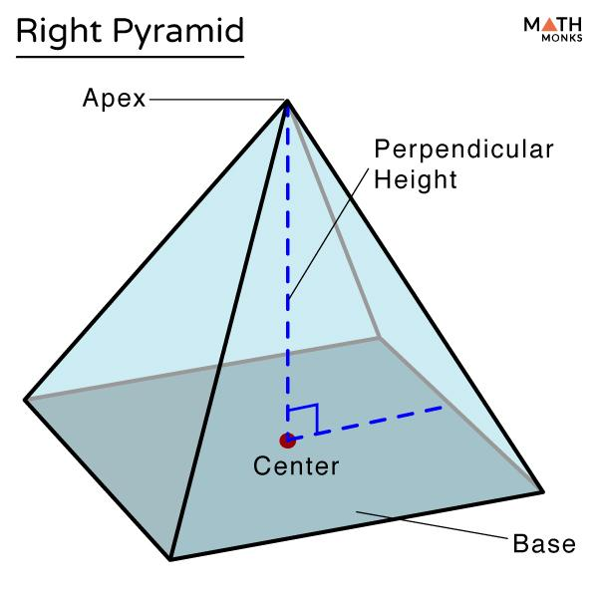
Right Triangular Pyramid
The perpendicular from the apex meets the specified center of the base. Its lateral faces and edges are not necessarily equal.
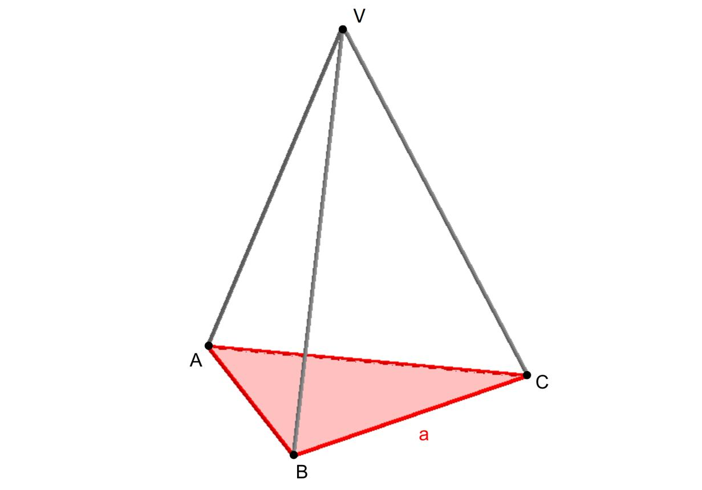
Oblique Triangular Pyramid
The perpendicular from the apex does not meet the designated base center. Its apex is displaced to one side relative to the base.
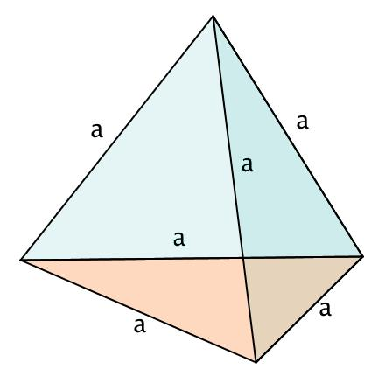
Regular Tetrahedron
All four faces are congruent equilateral triangles, and all six edges are equal. It is a special case of a right triangular pyramid when the apex is above the center of an equilateral base.
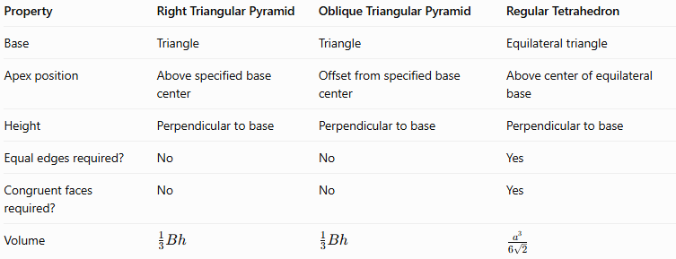
Property | Right Triangular Pyramid | Oblique Triangular Pyramid | Regular Tetrahedron
Base | Triangle | Triangle | Equilateral triangle
Apex position | Above specified base center | Offset from specified base center | Above center of equilateral base
Height | Perpendicular to base | Perpendicular to base | Perpendicular to base
Equal edges required? | No | No | Yes
Congruent faces required? | No | No | Yes
Volume | $$\frac{1}{3}Bh$$ | $$\frac{1}{3}Bh$$ | $$\frac{a^{3}}{6\sqrt{2}}$$

Applications
# Source: AI Source: Provided by: [Data Path: Persons Table -> ID Column: 1, Name_En Column: Motasem Essam] -> From: [ChatGPT] on [7/25/2026]
- Architecture: Designing pyramid-shaped roofs and structural supports.
- Engineering: Modeling solid components with triangular bases and a centrally positioned apex.
- Computer graphics: Creating three-dimensional mesh models.
- Mathematics education: Studying perpendicular height, spatial relationships, surface area, and volume.
- Geometric modeling: Comparing right and oblique pyramids and investigating the effect of moving the apex.

Key Points
# Source: AI Source: Provided by: [Data Path: Persons Table -> ID Column: 1, Name_En Column: Motasem Essam] -> From: [ChatGPT] on [7/25/2026]
- A right triangular pyramid has one triangular base and three triangular lateral faces.
- It has 4 faces, 6 edges, and 4 vertices.
- Its apex lies above the designated center of the base.
- Its perpendicular height meets the base plane at ${90}^{∘}$.
- The base triangle does not have to contain a right angle.
- Its lateral edges and lateral faces are not necessarily equal.
- Its volume is $V=\frac{1}{3}Bh$.
- Its total surface area is the sum of the areas of all four triangular faces.
- A regular tetrahedron is a special, highly symmetrical example.

Conclusion
# Source: AI Source: Provided by: [Data Path: Persons Table -> ID Column: 1, Name_En Column: Motasem Essam] -> From: [ChatGPT] on [7/25/2026]
A right triangular pyramid is a three-dimensional polyhedron whose apex is positioned directly above the specified center of its triangular base. Its defining feature is the perpendicular height from the apex to the base plane, not a right angle in the base triangle.
Although its four faces are triangular, they do not have to be congruent, and its six edges do not have to be equal. Understanding this solid helps distinguish pyramids by spatial orientation and provides a foundation for studying regular and oblique triangular pyramids.

